Functional Description

User interface:
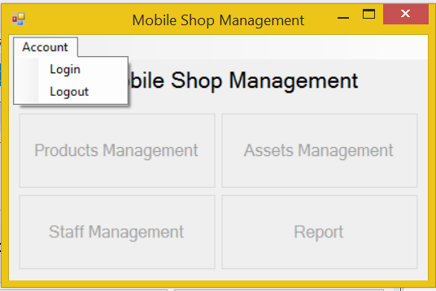
Screen | Mobile Shop Management – User interface
Description | Display a screen where user can control the product.
Screen Access | Users run program by click on file ProductManagement.exe
Screen Content
Item | Type | Data | Description
Mobile Shop Management | Label |  | Name of the software
Account | Menu strip item |  | Name of menu strip
Log in | Menu strip item |  | Open a dialog where user can log into program
Log out | Menu strip item |  | Log out the program.
Products Management | Button |  | If user click on this button, the “Products Management” dialog will appear.
Assets Management | Button |  | If user click on this button, the “Assets Management” dialog will appear.
Staff Management | Button |  | If user click on this button, the “Staff Management” dialog will appear.
Report | Button |  | If user click on this button, the “Report” dialog will appear.
Screen Actions
Action Name | Description |  | Success | Failure
Log in | Everyone have an account and click on it to enter the system. |  | Username of current user will display at the bottom of screen and all buttons will be enabled. | Displays message “Username or password is incorrect.”
Log out | Use to exit the system. |  | Username of current user at the bottom of screen will be disappeared and all button will be disabled. | Nothing.
Products Management | Search data which existed in database |  | “Products Management” dialog opened | Nothing.
Assets Management | Add more data. |  | “Assets Management” dialog opened | Nothing.
Staff Management | Remove some of data. |  | “Staff Management” dialog opened | Nothing.
Report | Update some exist fields of data. |  | “Report” dialog opened | Nothing.

Products Management:
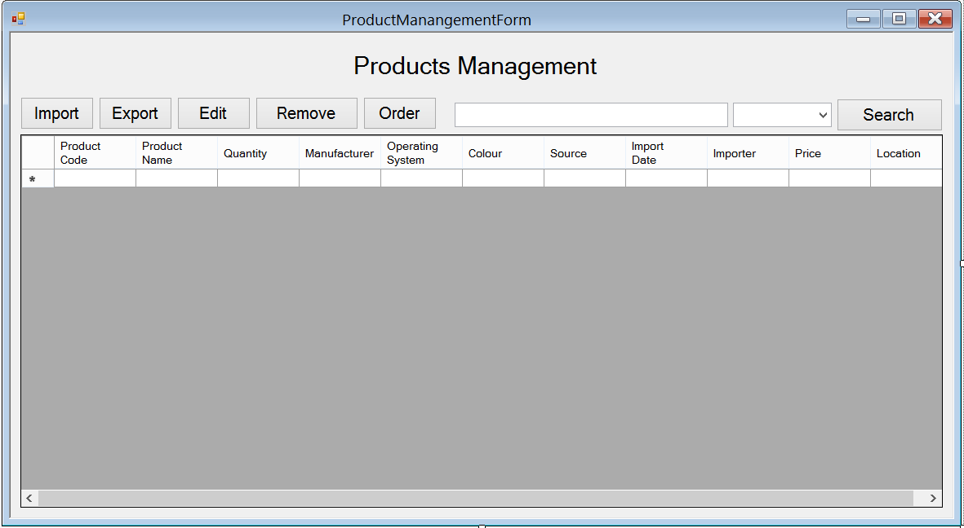
Screen | Products Management
Description |  | Show information of product, user can import new products, export(sell) them, edit their information, remove them. In case they run out of some products, they could order some more.
Screen Access |  | Users run program then click on Products Management button
Screen Content
Item |  | Type | Data | Description
Data grid view |  | Data grid view | Lookup all fields from PRODUCT table. | - Display all fields about the product when the form loaded: Product code, product name, quantity, manufacturer, OS, colour, source, import date, importer, price, location.  - This table is read-only, user cannot edit it.
Import |  | Button |  | User click on it to add new product
Export |  | Button |  | User click on it to add information of selling product into database
Edit |  | Button |  | User click on it to edit information of product
Remove |  | Button |  | User click on it to remove products in case they stop selling them
Order |  | Button |  | When the store run out of some product,or some new products that they don’t have, they could order their distributor to get them.
Search |  | Button |  | Search products by name, manufactor, price
Textbox |  | Text field – String (50) |  | Enter the keyword that user want to search
Combo box |  | Drop down list |  | User choose which field they want to search by: name, manufactor, price
Screen Actions
Action Name |  | Description |  | Success | Failure
Import |  | Add information of new product |  | New product is added to database, show a message to notice | Show a message to notice, ask user to check the information and retry
Export |  | Add information of selling product |  | Show a message to ask the user to confirm that information | Show a message to notice, ask user to check the information and retry
Edit |  | Edit information of product |  | Show a message to ask the user to confirm that information | Show a message to notice, ask user to check the information and retry
Remove |  | Remove information of product |  | Show a message to ask the user if they comfirm to delete | Show a message to notice
Order |  | Make an order for new product |  | Show a message to ask the user if they comfirm to add information about order | Show a message to notice, ask user to check the information and retry
Search |  | Find a product in the table below. |  | Return the result of searching process | Message “Not found”.

Products Management – Import
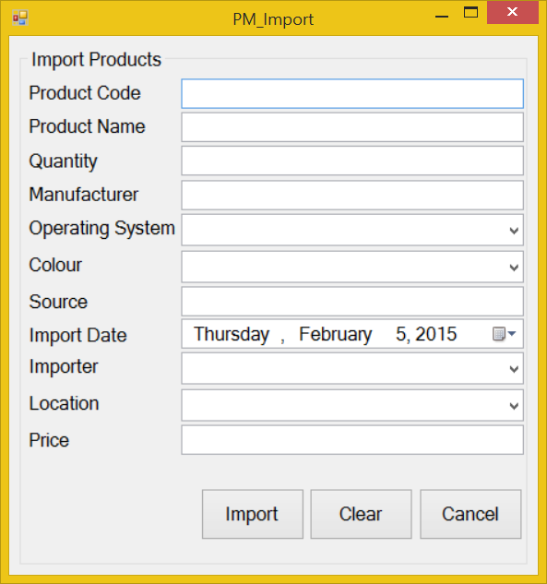
Screen | Product Management - Import
Description | Add new product into data base
Screen Access | Users run program by click on file Product Management -> Import
Screen Content
Item | Type | Data | Description
Import Products | String (50) | Hard code | A title lable
Product Name | Text field – String (50) | User input | The name of product
Quantity | Text field – String (50) | User input | The quantity of product
Manufacturer | Dropdown list – String (50) | Table MANUFACTURE.NAME | The name of the manufacture
Operating System | Dropdown list – String (50) | Table OPERATINGSYSTEM.NAME | The name of the Operating System
Colour | Dropdown list – String (50) | Table COLOR.NAME | The color of Product
Source | Text field – String (50) | User input | Where the product has been made?
Import Date | Date time picker |  | When the product was imported?
Importer | Dropdown list – String (50) | Table STAFF.NAME | Who import that product?
Location | Dropdown list – String (50) | Table Warehouse.Name | Where they contain the product?
Price | Text field – String (50) | User input | The price of the product
Import | Button |  | Inport new product
Clear | Button |  | Clear all the fields
Cancel | Button |  | Cancel importing action
Screen Actions
Action Name | Description |  | Success | Failure
Import | Inport new product |  | Show a message to notice | Show a message to notice, ask user to try
Clear | Clear all the fields |  | Set all the field empty,set all dropdown-list to default
Cancel | Cancel importing action |  | Close the import form

Products Management – Export
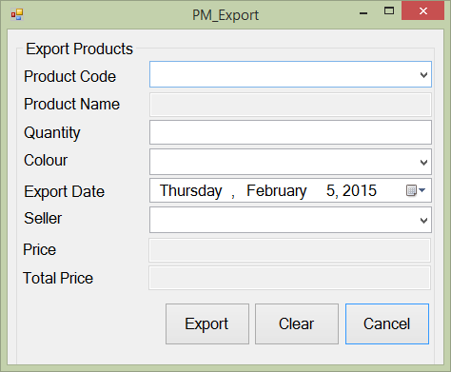
Screen | Product Management - Export
Description | Add information about selling product
Screen Access | Users run program by click on file Product Management -> Export
Screen Content
Item | Type | Data | Description
Export Products | String (50) |  | Title
Product Code | Dropdown list – String (50) | Table PHONE.PRODUCTCODE | The code of the product
Product Name | Text field – String (50) | Table PHONE.PRODUCTNAME | The name of the product
Quantity | Text field – String (50) | User input | The quantity of the product
Colour | Dropdown list – String (50) | Table COLOR.COLOR | The color of the product
Export Date | Date time picker |  | When the product was exported?
Seller | Dropdown list – String (50) | Table STAFF.CODE | Who sold the product?
Price | Text field – String (50) | PHONE.PRICE | The price of product
Total Price | Text field – String (50) | Price*Quantity | The total price of all product have been sold
Export | Button |  | Add information about selling product
Clear | Button |  | Clear all the fields
Cancel | Button |  | Close Export form
Screen Actions
Action Name | Description |  | Success | Failure
Export | Add information about selling product |  | Show a message to ask for confirmation, show message to notice the information has been added to database | Show a message to notice, ask user to try
Clear | Clear all the fields
Cancel | Close Export form |  | Show a message to ask if they wanted to close the field

Products Management – Edit
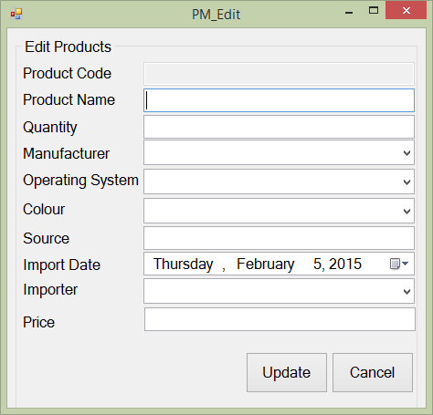
Screen | Product Management - Edit
Description | Edit information of product
Screen Access | Users run program by click on file Product Management -> Edit
Screen Content
Item | Type | Data | Description
Edit Products | String (50) |  | Title
Product Code | Text field – String (50) | Table PHONE.CODE | The code of product
Product Name | Text field – String (50) | Table PHONE.NAME | The name of product
Quantity | Text field – String (50) | Table User input | The quantity of product
Manufacturer | Dropdown list – String (50) | Table MANUFACTURE.NAME | The manufacture of product
Operating System | Dropdown list – String (50) | Table OPERATINGSYSTEM.NAME | The operation system of product
Colour | Dropdown list – String (50) | Table COLOR.VALUE | The color of product
Source | Text field – String (50) | Table PHONE.SOURCE | Where the product has been made?
Import Date | Date time picker |  | When the product has been imported?
Importer | Dropdown list – String (50) | STAFF.CODE | Who imported the product?
Price | Text field – String (50) | Table PHONE.PRICE | The price of product
Update | Button |  | Click to update
Cancel | Button |  | Click to close the form
Screen Actions
Action Name | Description |  | Success | Failure
Update | Update phone |  | Show a mesage to notice | Show a mesage to notice, ask user to retry
Cancel | Close the form

Products Management – Order

Order – Order Products
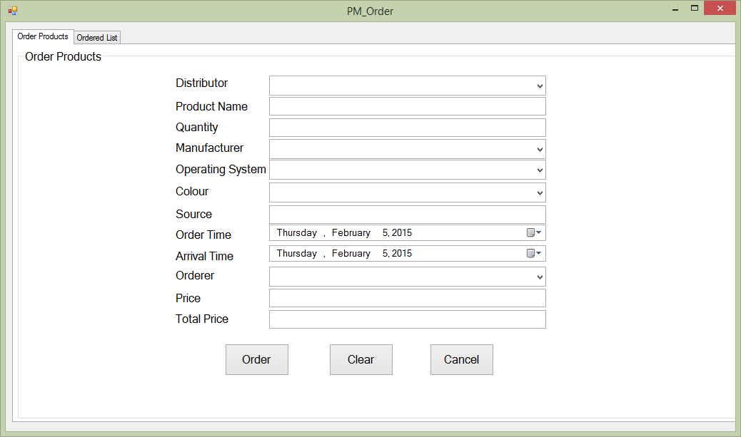
Screen | Product Management – Order
Description | Order the distributor new product in case they run out of product
Screen Access | Users run program by click on file Product Management -> Order
Screen Content
Item | Type | Data | Description
Order Products | Tab
Order Products | String (50) |  | Title
Distributor | Dropdown list – String (50) | DISTRIBUTOR.NAME | Who distribute that product?
Product Name | Text field – String (50) | User input | The name of the product
Quantity | Text field – String (50) | User input | The quantity of the product
Manufacturer | Dropdown list – String (50) | Table MANUFACTURER.NAME | The manufacturer of the product
Operating System | Dropdown list – String (50) | Table OPERATINGSYSTEM.NAME | The operating system of the product
Colour | Dropdown list – String (50) | Table COLOR.VALUE | The color of the product
Source | Text field – String (50) | User input | Where the product has been made?
Order Time | Date time picker |  | When did they ordered them?
Arrival Time | Date time picker |  | When will the product arrive?
Orderer | Dropdown list – String (50) | STAFF.CODE | Who ordered this product?
Price | Text field – String (50) | User input | The price of the product
Total Price | Text field – String (50) | Price*Quantity | The total price of all the products has been ordered
Order | Button |  | Add to database
Clear | Button |  | Clear all the fields
Cancel | Button |  | Close the form
Screen Actions
Action Name | Description |  | Success | Failure
Order | Add to database |  | Show a mesage to notice | Show a mesage to notice, ask user to retry
Clear | Clear all the fields |  | Set all the fields to empty
Cancel | Close the form |  | Close the form

Order – Ordered List
Screen | Products Management
Description
Screen Access |  | Users run program then click on Products Management button
Screen Content
Item |  | Type | Data | Description
Ordered List |  | Tab
Ordered List |  | String (50)
Data grid view |  | Data grid view |  | - Display all fields about the ordered list when the form loaded: Distributor, product name, quantity, manufacturer, OS, colour, source, order time, arrival time, ordered, price, total price, status.  - This table is read-only, user cannot edit it.
Verify Order |  | Button
Remove Order |  | Button
Cancel Order |  | Button
Screen Actions
Action Name |  | Description |  | Success | Failure
Verify Order
Remove Order
Cancel Order

Assets Management:
Use Case Name | Add products
Use Case ID | ABC001
High Level Requirement Ref | The general information about imported products must be prepared. The manager and the others members who have authority can view the product list. Besides that, they can make the order to import more products.
Actor | Shop’s Master, Warehouse Manager, Treasurer, Accountant
Description | This use case is used to add more products.
Pre-condition | The product is not available in the database.
Post-processing | The database has new products.

Screen | Assets Management
Description
Screen Access |  | Users run program then click on Assets Management button
Screen Content
Item |  | Type | Data | Description
Data grid view |  | Data grid view | Lookup all fields from ASSET table. | - Display all fields about the asset when the form loaded: asset code, type, asset name, quantity, manufacturer, colour, source, import date, importer, location, price.  - This table is read-only, user cannot edit it.
Import |  | Button |  | User click on it to add new product
Export |  | Button |  | User click on it to add information of selling product into database
Edit |  | Button |  | User click on it to edit information of product
Remove |  | Button |  | User click on it to remove products in case they stop selling them
Order |  | Button |  | When the store run out of some product,or some new products that they don’t have, they could order their distributor to get them.
Search |  | Button |  | Search products by name, manufactor, price
Textbox |  | Text field – String (50) |  | Enter the keyword that user want to search
Combo box |  | Drop down list |  | User choose which field they want to search by: name, manufactor, price
Screen Actions
Action Name |  | Description |  | Success | Failure
Import |  | Add information of new product |  | New product is added to database, show a message to notice | Show a message to notice, ask user to check the information and retry
Export |  | Add information of selling product |  | Show a message to ask the user to confirm that information | Show a message to notice, ask user to check the information and retry
Edit |  | Edit information of product |  | Show a message to ask the user to confirm that information | Show a message to notice, ask user to check the information and retry
Remove |  | Remove information of product |  | Show a message to ask the user if they comfirm to delete | Show a message to notice
Order |  | Make an order for new product |  | Show a message to ask the user if they comfirm to add information about order | Show a message to notice, ask user to check the information and retry
Search |  | Find a product in the table below. |  | Return the result of searching process | Message “Not found”.

Assets Management – Import
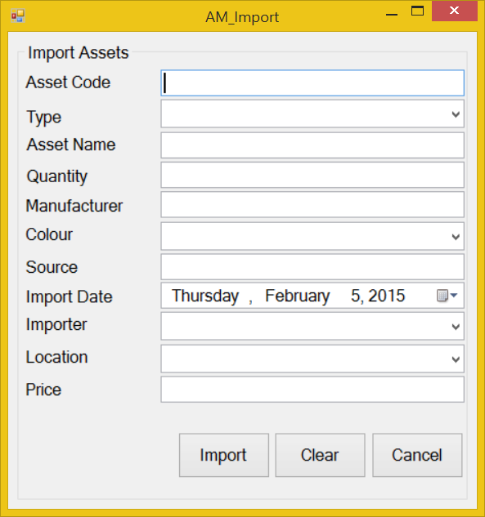
Screen | Product Management - Import
Description | Add new product into data base
Screen Access | Users run program by click on file Product Management -> Import
Screen Content
Item | Type | Data | Description
Import Products | String (50) | Hard code | A title lable
Product Name | Text field – String (50) | User input | The name of product
Quantity | Text field – String (50) | User input | The quantity of product
Manufacturer | Dropdown list – String (50) | Table MANUFACTURE.NAME | The name of the manufacture
Operating System | Dropdown list – String (50) | Table OPERATINGSYSTEM.NAME | The name of the Operating System
Colour | Dropdown list – String (50) | Table COLOR.NAME | The color of Product
Source | Text field – String (50) | User input | Where the product has been made?
Import Date | Date time picker |  | When the product was imported?
Importer | Dropdown list – String (50) | Table STAFF.NAME | Who import that product?
Location | Dropdown list – String (50) | Table Warehouse.Name | Where they contain the product?
Price | Text field – String (50) | User input | The price of the product
Import | Button |  | Inport new product
Clear | Button |  | Clear all the fields
Cancel | Button |  | Cancel importing action
Screen Actions
Action Name | Description |  | Success | Failure
Import | Inport new product |  | Show a message to notice | Show a message to notice, ask user to try
Clear | Clear all the fields |  | Set all the field empty,set all dropdown-list to default
Cancel | Cancel importing action |  | Close the import form

Assets Management – Export
Screen | Product Management - Export
Description | Add information about selling product
Screen Access | Users run program by click on file Product Management -> Export
Screen Content
Item | Type | Data | Description
Export Products | String (50) |  | Title
Product Code | Dropdown list – String (50) | Table PHONE.PRODUCTCODE | The code of the product
Product Name | Text field – String (50) | Table PHONE.PRODUCTNAME | The name of the product
Quantity | Text field – String (50) | User input | The quantity of the product
Colour | Dropdown list – String (50) | Table COLOR.COLOR | The color of the product
Export Date | Date time picker |  | When the product was exported?
Seller | Dropdown list – String (50) | Table STAFF.CODE | Who sold the product?
Price | Text field – String (50) | PHONE.PRICE | The price of product
Total Price | Text field – String (50) | Price*Quantity | The total price of all product have been sold
Export | Button |  | Add information about selling product
Clear | Button |  | Clear all the fields
Cancel | Button |  | Close Export form
Screen Actions
Action Name | Description |  | Success | Failure
Export | Add information about selling product |  | Show a message to ask for confirmation, show message to notice the information has been added to database | Show a message to notice, ask user to try
Clear | Clear all the fields
Cancel | Close Export form |  | Show a message to ask if they wanted to close the field

Assets Management – Edit
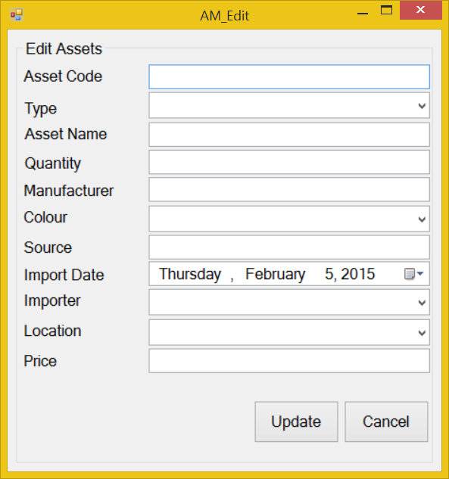
Screen | Product Management - Edit
Description | Edit information of product
Screen Access | Users run program by click on file Product Management -> Edit
Screen Content
Item | Type | Data | Description
Edit Products | String (50) |  | Title
Product Code | Text field – String (50) | Table PHONE.CODE | The code of product
Product Name | Text field – String (50) | Table PHONE.NAME | The name of product
Quantity | Text field – String (50) | Table User input | The quantity of product
Manufacturer | Dropdown list – String (50) | Table MANUFACTURE.NAME | The manufacture of product
Operating System | Dropdown list – String (50) | Table OPERATINGSYSTEM.NAME | The operation system of product
Colour | Dropdown list – String (50) | Table COLOR.VALUE | The color of product
Source | Text field – String (50) | Table PHONE.SOURCE | Where the product has been made?
Import Date | Date time picker |  | When the product has been imported?
Importer | Dropdown list – String (50) | STAFF.CODE | Who imported the product?
Price | Text field – String (50) | Table PHONE.PRICE | The price of product
Update | Button |  | Click to update
Cancel | Button |  | Click to close the form
Screen Actions
Action Name | Description |  | Success | Failure
Update | Update phone |  | Show a mesage to notice | Show a mesage to notice, ask user to retry
Cancel | Close the form

Assets Management – Order
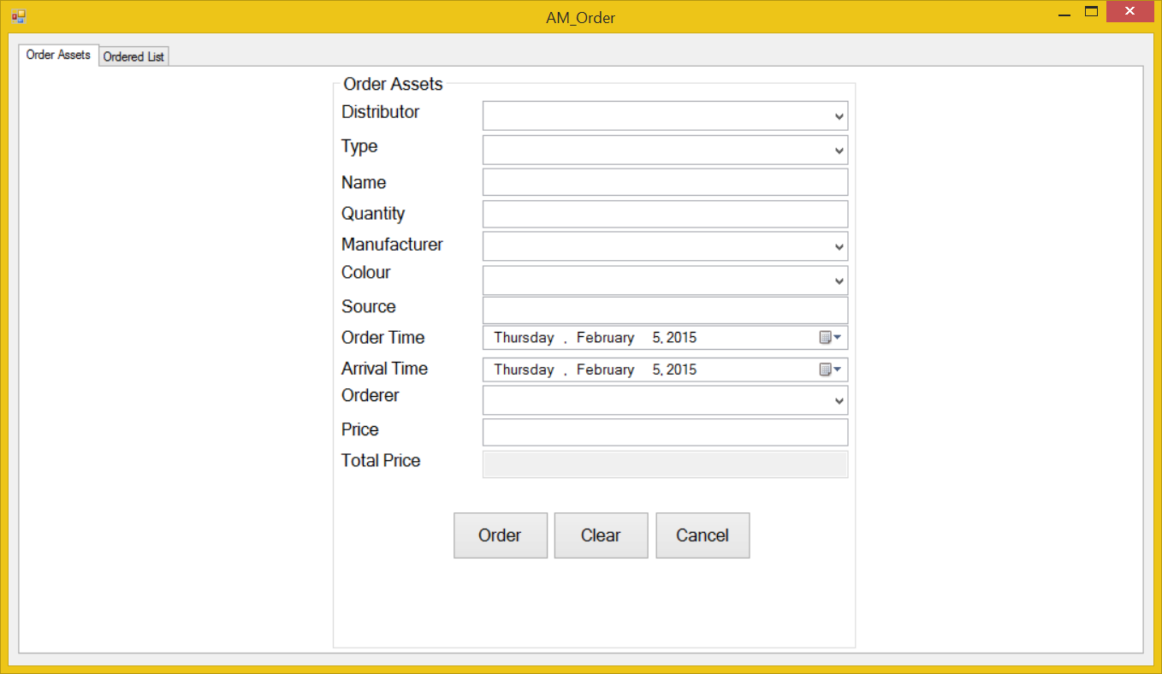
Screen | Product Management – Order
Description | Order the distributor new product in case they run out of product
Screen Access | Users run program by click on file Product Management -> Order
Screen Content
Item | Type | Data | Description
Order Products | Tab
Order Products | String (50) |  | Title
Distributor | Dropdown list – String (50) | DISTRIBUTOR.NAME | Who distribute that product?
Product Name | Text field – String (50) | User input | The name of the product
Quantity | Text field – String (50) | User input | The quantity of the product
Manufacturer | Dropdown list – String (50) | Table MANUFACTURER.NAME | The manufacturer of the product
Operating System | Dropdown list – String (50) | Table OPERATINGSYSTEM.NAME | The operating system of the product
Colour | Dropdown list – String (50) | Table COLOR.VALUE | The color of the product
Source | Text field – String (50) | User input | Where the product has been made?
Order Time | Date time picker |  | When did they ordered them?
Arrival Time | Date time picker |  | When will the product arrive?
Orderer | Dropdown list – String (50) | STAFF.CODE | Who ordered this product?
Price | Text field – String (50) | User input | The price of the product
Total Price | Text field – String (50) | Price*Quantity | The total price of all the products has been ordered
Order | Button |  | Add to database
Clear | Button |  | Clear all the fields
Cancel | Button |  | Close the form
Screen Actions
Action Name | Description |  | Success | Failure
Order | Add to database |  | Show a mesage to notice | Show a mesage to notice, ask user to retry
Clear | Clear all the fields |  | Set all the fields to empty
Cancel | Close the form

Order – Order Products
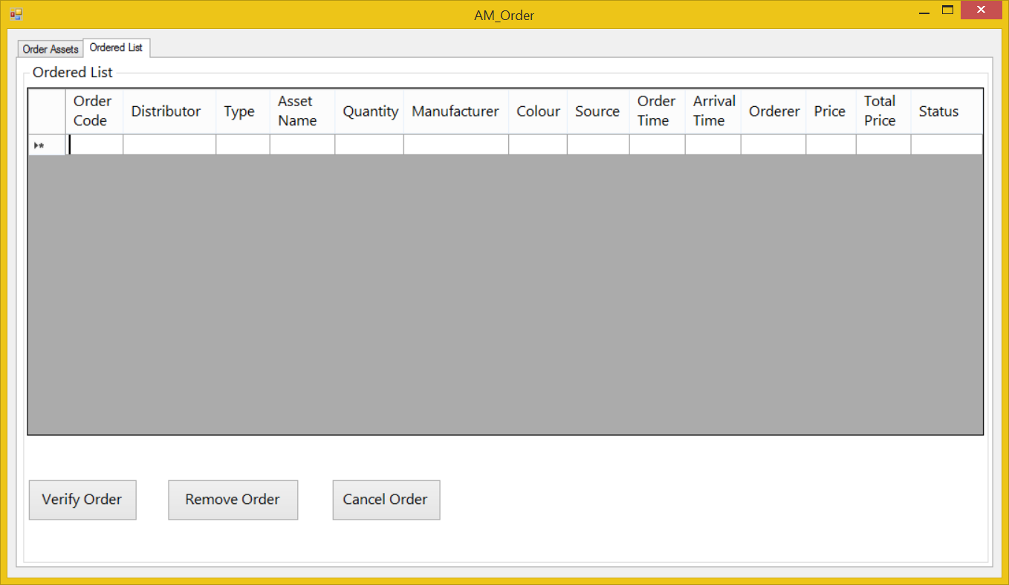
Screen | Product Management – Order
Description | Manage order
Screen Access | Users run program by click on file Order
Screen Content
Item | Type | Data | Description
Order List | Label |  | Title
Order table | Data grid view | Table ORDER | Show order information
Verify order | Button |  | Verify order
Remove order | Button |  | Remove order
Cancel order | Button |  | Cancel order
Screen Actions
Action Name | Description |  | Success | Failure
Verify order | Verify order |  | Show a mesage to notice | Show a mesage to notice, ask user to retry
Remove order | Remove order |  | Show a mesage to notice, ask for confirmation | Show a mesage to notice, ask user to retry
Cancel order | Cancel order |  | Close the form

Order – Ordered List
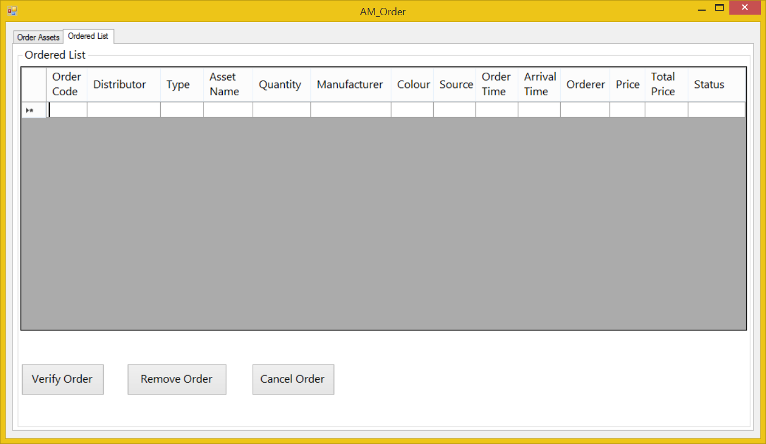
Screen | Product Management – Order
Description | Manage order
Screen Access | Users run program by click on file Order
Screen Content
Item | Type | Data | Description
Order List | Label |  | Title
Order table | Data grid view | Table ORDER | Show order information
Verify order | Button |  | Verify order
Remove order | Button |  | Remove order
Cancel order | Button |  | Cancel order
Screen Actions
Action Name | Description |  | Success | Failure
Verify order | Verify order |  | Show a mesage to notice | Show a mesage to notice, ask user to retry
Remove order | Remove order |  | Show a mesage to notice, ask for confirmation | Show a mesage to notice, ask user to retry
Cancel order | Cancel order |  | Close the form

Staff Management
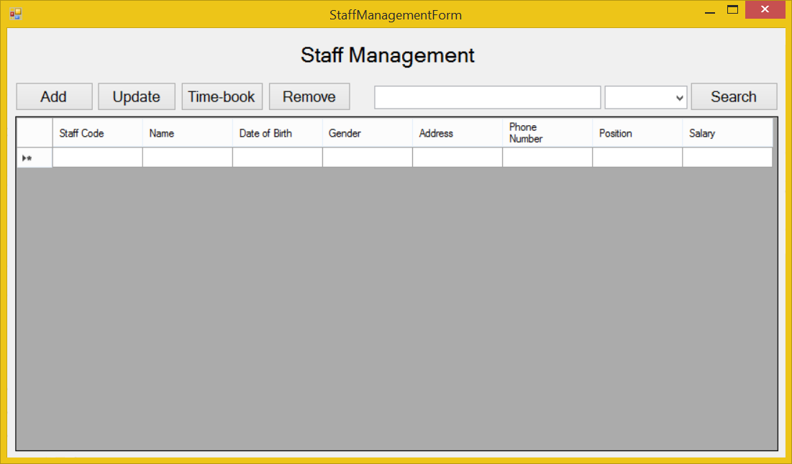

Staff Management – Add
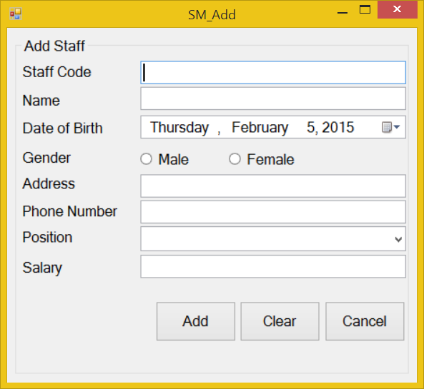

Staff Management – Update

Staff Management – Time-book

Report

Report – Total Statics

Report – Staff Statics

Report – Product Statics

